**Problem Statement 2 :- Prepare and Verify an employee database file (EMP) that contains employee records under the following column.**

**EMP ID, EMP First_Name, EMP Last_Name, Location, Designation, Net Salary, Specialization, Project, Joining Month, Joining Year.**

Design, Execute and Analyze AWK Script for the following problem statements.

**2.1** Create and Execute AWK script to display EMP ID, EMP First_Name, EMP Last_name, Location, and Designation of employees having designations as 'Manager.

**2.2** Create and Execute AWK script to display EMP ID, EMP First_Name, EMP Last_Name, Location and Designation of employees who are specialized in Java Programming and are working at Delhi and Pune locations.

**2.3** Create and Execute AWK script to display EMP ID, EMP First_Name, EMP Last_Name, Location, Designation, Joining Month and Joining Year of all those employees who joined after January 2000 but before December 2005.

**2.4** Create and Execute AWK script to display all fields of all those employees who joined the Organization on the net salary in between 45000 to 65000, during the period January 2000 to December 2005.

**2.5** Create and Execute AWK script to display all fields of all those employees whose last name is "Kumar".

**Objective :-** To design and analyze an employee database using AWK scripting in order to perform efficient data extraction and filtering operations. By preparing the employee database file (EMP) with attributes such as EMP ID, Name, Location, Designation, Salary, Specialization, Project, and Joining details, and then executing AWK scripts, we aim to:

1. Retrieve employee details based on specific conditions such as designation (e.g., Manager), specialization (e.g., Java Programming), and location (Delhi, Pune).
2. Extract employees' joining details within a given time period (e.g., between Jan 2000 and Dec 2005).
3. Identify employees within a specific salary range along with joining period constraints.
4. Display complete records of employees based on last name filtering (e.g., “Kumar”).

**2.1** Create and Execute AWK script to display EMP ID, EMP First_Name, EMP Last_name, Location, and Designation of employees having designations as 'Manager.

**Objective :-** To develop and run an AWK script that extracts and displays the employee ID (EMP_ID), First name (EMP_First_name), last name(Emp_last_name),location, and designation of employees whose designation is ‘Manager’ from a given dataset . This script will enhance data analysis and facilitate quick access to relevant employee information for management purposes.

**Output :**

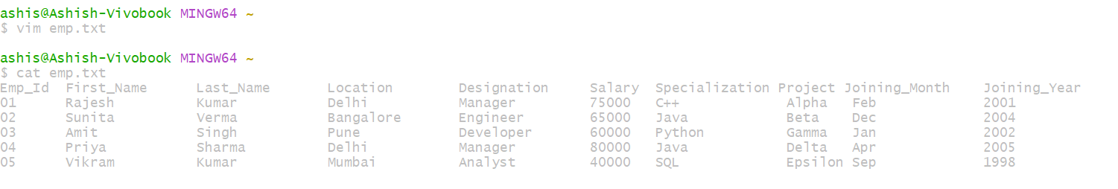

**AWK Script:**

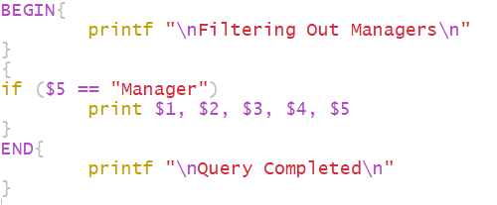

**Output :**

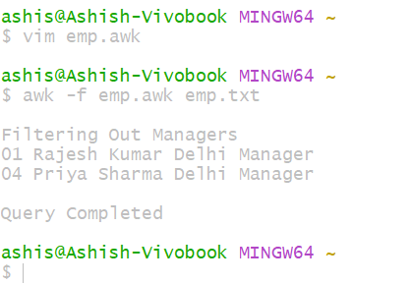

**2.2** Create and Execute AWK script to display EMP ID, EMP First_Name, EMP Last_Name, Location and Designation of employees who are specialized in Java Programming and are working at Delhi and Pune locations.

**Objective :-** To develop and run an AWK script that extracts and displays the employee ID (EMP_ID), First name (EMP_First_name), last name(Emp_last_name),location, and designation of employees who are specialized in Java Programming and Working in delhi and pune locations from a given dataset . This script will enhance data analysis and facilitate quick access to relevant employee information for management purposes.

**AWK Script:**

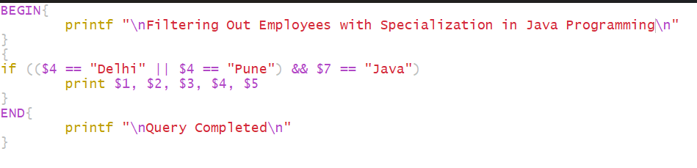

**Output :**

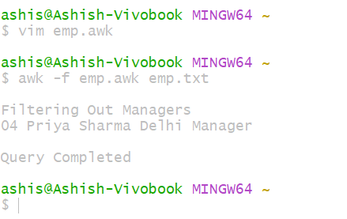

**2.3** Create and Execute AWK script to display EMP ID, EMP First_Name, EMP Last_Name, Location, Designation, Joining Month and Joining Year of all those employees who joined after January 2000 but before December 2005.

**Objective :-** To develop and run an AWK script that extracts and displays the employee ID (EMP_ID), First name (EMP_First_name), last name(Emp_last_name),location, designation,Joining month and joining year of employees who joined in a given timeframe from a given dataset . This script will enhance data analysis and facilitate quick access to relevant employee information for management purposes.

**AWK Script:**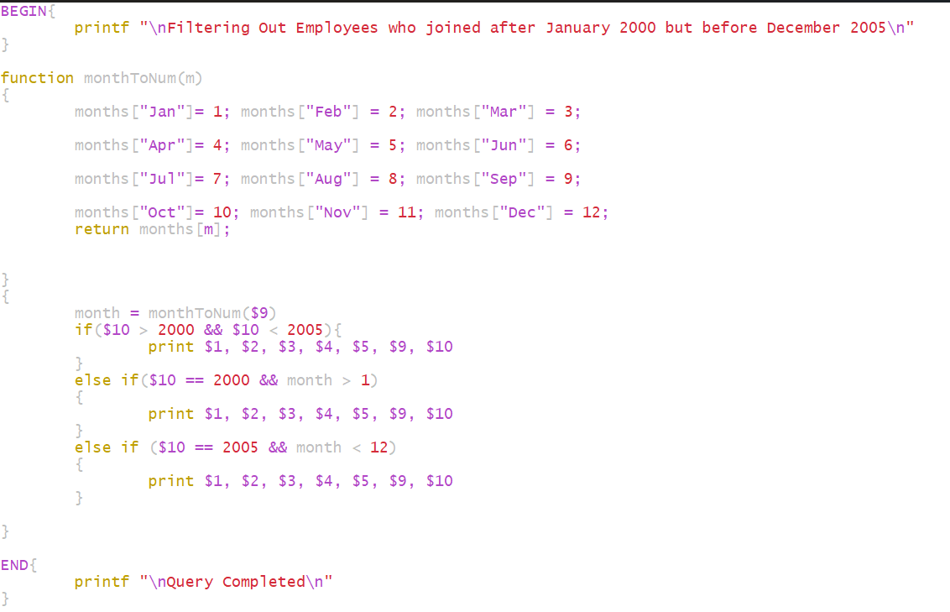

**Output :**

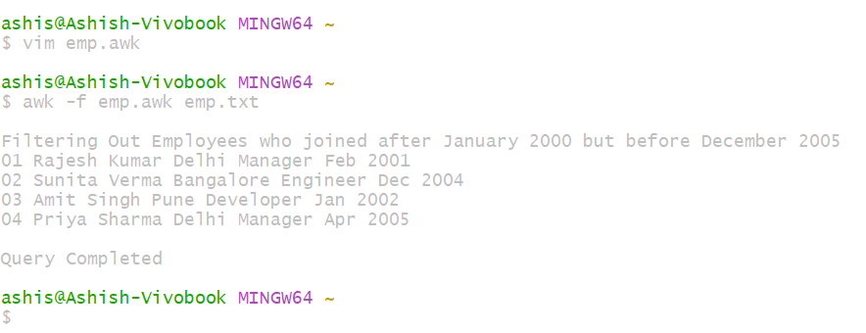

**2.4** Create and Execute AWK script to display all fields of all those employees who joined the Organization on the net salary in between 45000 to 65000, during the period January 2000 to December 2005.

**Objective :-** To develop and run an AWK script that extracts and displays the the data of those employees who joined in a given timeframe in a given salary range from a given dataset . This script will enhance data analysis and facilitate quick access to relevant employee information for management purposes.

**AWK Script:**

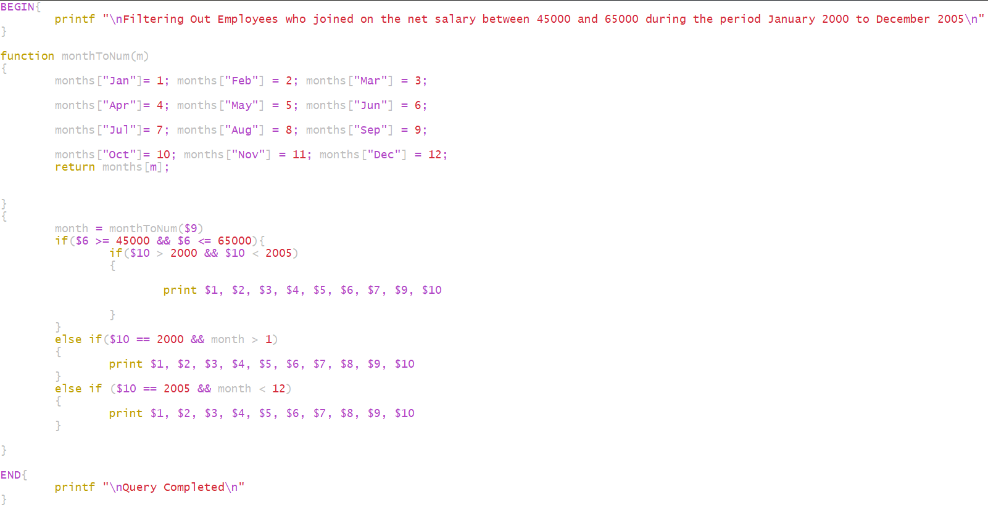

**Output :**

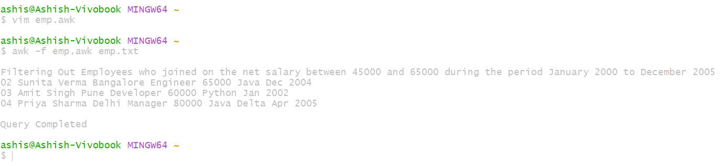

**2.5** Create and Execute AWK script to display all fields of all those employees whose last name is "Kumar".

**Objective :-** To develop and run an AWK script that extracts and displays the the data of those employees who who have a specific Surname from a given dataset . This script will enhance data analysis and facilitate quick access to relevant employee information for management purposes.

**AWK Script:**

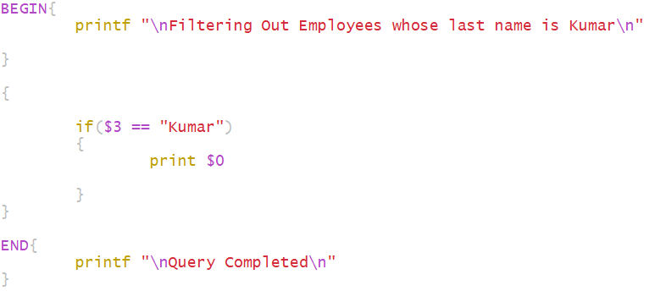

**Output :**

